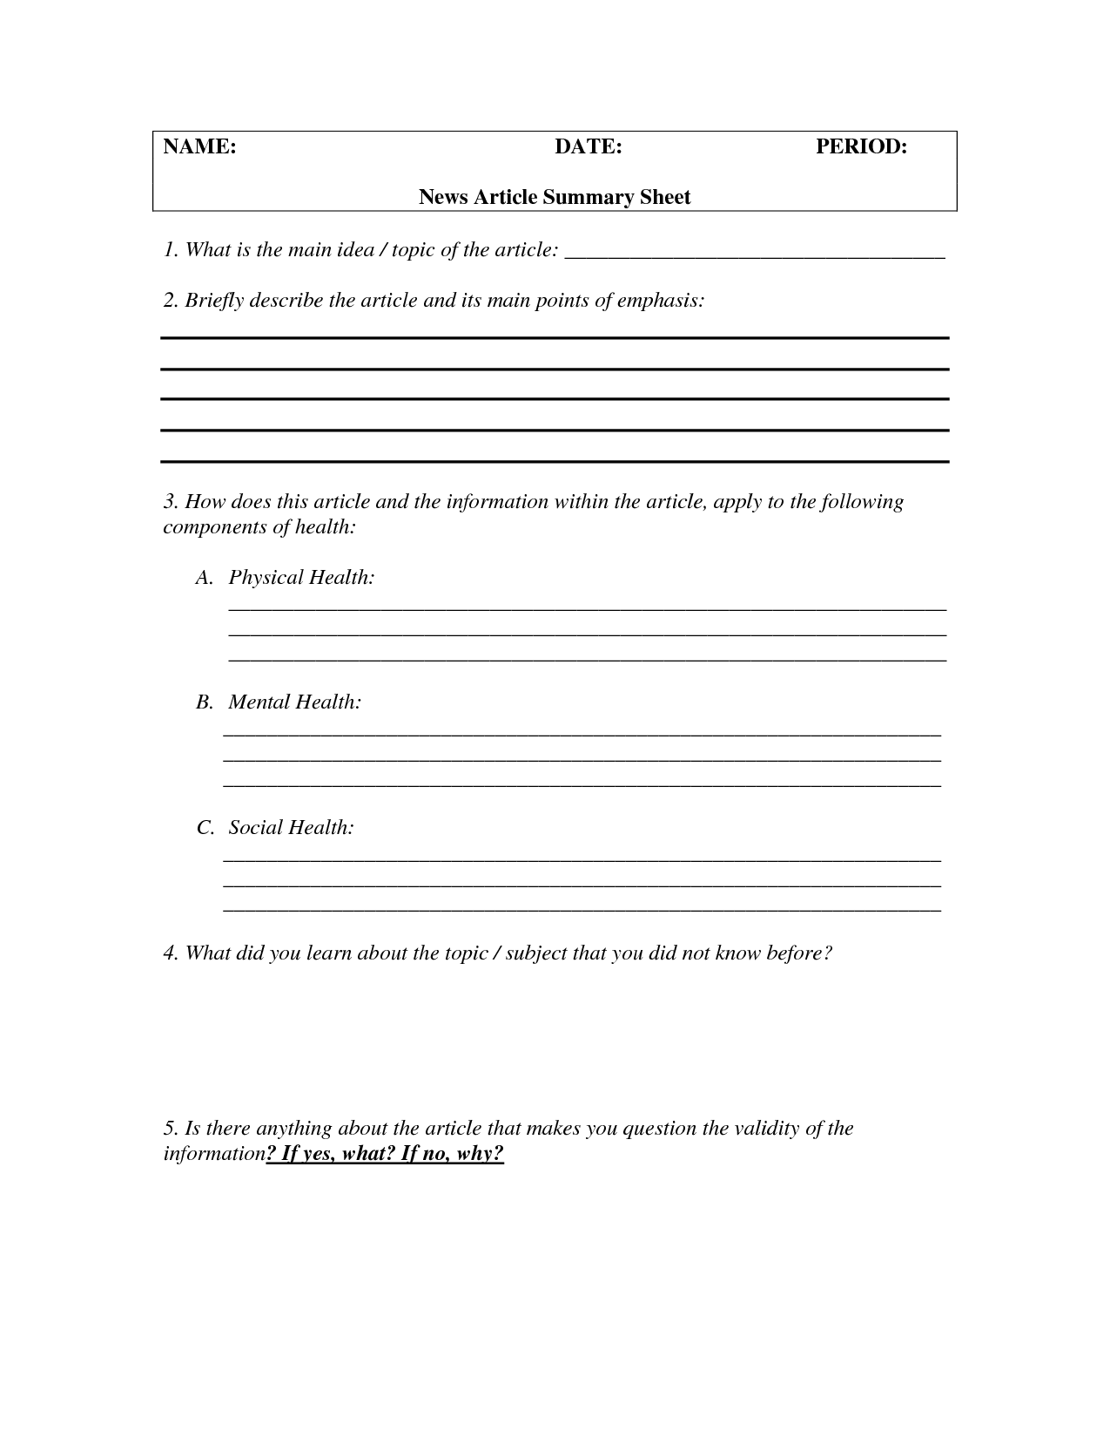
What was the most surprising/interesting thing you found out by reading this article? What questions do you have after reading this article? What would you like to learn more about?

