Badminton Rules Poster

Task: You are to design a badminton poster that includes the following information. All posters must be submitted to Mr. Mitchell or Mrs. Penner via OneDrive.
E-mail addresses: dmitchell@pembinatrails.ca or spenner@pembinatrails.ca
Requirements:
- History
- General rules
- Service Area (use a picture of illustration)
- Doubles Play
- Singles Play
- Scoring
- Terminology
- Bird
- Drive shot
- Drop shot
- Clear shot
- Let
- Rally
- QR Code demonstrating 2 skills being executed
- https://www.qr-code-generator.com/how-to-create-a-qr-code/
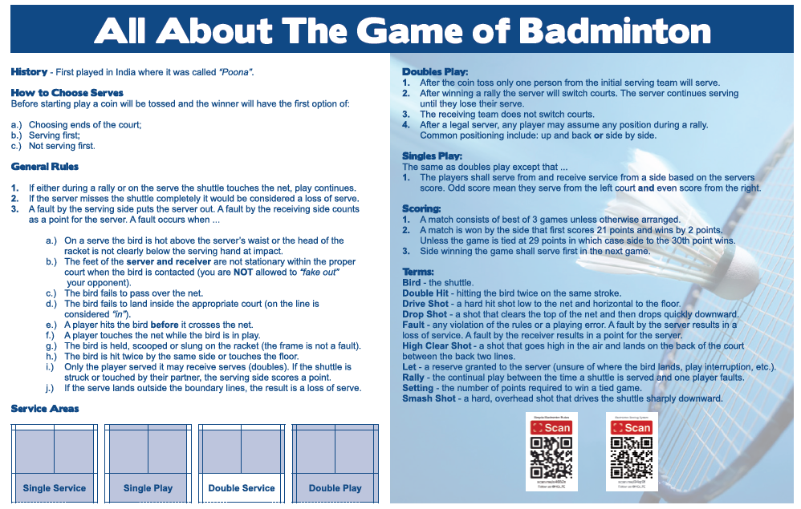
Example:

